DESIGN OF PIEZOELECTRIC POWER PLANT IN SLEEP POLICE BASED ON BLUFF BODY BASED ON KANTILEVER SYSTEM

Yusniati¹, Tri Hernawati²
^{1,2} Lecture Electrical Engineering, Universitas Islam Sumatera Utara (UISU)
Medan, North Sumatera, Indonesia

ABSTRACT

Indonesia need for electricity predicted increase every year, this can cause Indonesia to become an energy importer in the coming year. These problems can be overcome by developing alternative energy, one of which is utilizing waste vibration energy or pressure energy from the movement of motorized vehicles, cars and pedestrians and even gusts of wind in the use of piezoelectric speed bumps. Piezoelectric is an energy harvester. Piezoelectric with cantilever mechanism produces vibrations and deflections repeatedly, causing electrical voltage. Piezoelectric speed bump designed in this study consists of a speed bump system that serves to receive input from motor vehicle pressure, a piezoelectric cantilever system as a component of producing electrical energy and a harvesting energy system as a harvester of energy from piezoelectric material. One system module consists of a piezoelectric parallel circuit connected with a buck converter MB39C811. In this paper, we will discuss the mechanism of design analysis and modeling of piezoelectric power generation systems in bluff body-based speed bumps with cantilever systems to variations in speed of motorized vehicles by means of physical modeling. In the bluff body piezoelectric bump, it is seen that the flow of air as it passes through a triangle section increases in speed so that the vortex produced has a high speed. This is what causes high vibrations in the piezoelectricity so that the maximum electric voltage and the average electric voltage have the highest value. Piezoelectric speed bumps are capable of producing electrical power with 60 times the input of a motorized vehicle over 2,166mWh with an efficiency of 2.87% compared to manual input.
Keywords: piezoelectric, speed bump, electric energy, cantilever, bluff body.

I. INTRODUCTION

Electricity usage in daily life greatly affects the future. The electricity we use now comes from power plants that use fuel oil, coal, and others. One time the fuel we use will run out. With that we must create Alternative Energy that can be used in the long run (Solly Aryza et al., 2015). There are various examples of Alternative energy, for example we can apply is Electric Piezo. For example the use of electricity in a campus environment, we can replace it with electric piezo. With the example of installing piezoelectric in a speed bump by utilizing pressure force in the campus road area, Installing Buzzer Piezoelectric as a source of electrical energy in campus garden lights (Waheedabeevi & Sukeshkumar, 2012).
Speed ​​bumps or speed bump itself is found in many highways which generally have relatively high interactions between humans and motorized vehicles and therefore speed bumps function to slow down the speed of vehicles going through the road to reduce the risk of accidents. Pressure exerted by motorized vehicles through speed bumps can be utilized for the business of extracting or harvesting electrical energy with the principle of electric Piezo (Kar et al., 2011).
The word piezoelectric comes from Latin, piezein which means squeezed or pressed and electric which means electrical energy.

36
So the understanding of Piezoelectric itself is an energy harvester that can convert vibrations or pressure energy into electrical energy, so that the piezoelectric effect occurs due to the electric fields that are formed because the material is subjected to mechanical pressure (Waheedabeevi & Sukeshkumar, 2012).

Utilization of piezoelectric material can produce a large enough potential difference so that it is widely used as a source of high voltage and medium voltage. Piezoelectric has begun to be used in several Asian countries, one of which is in Japan (A. H. Lubis, 2018).
At this writing explains the analysis of the development of piezoelectricity which is focused on making a mechanical system in the form of speed bumps or basically bumps which is a prominent road with a height of about 3-5 inches which is usually found in areas that have interactions between people and vehicles relatively high motorized, One of which is the campus environment by considering the design and modeling of the harvesting energy system (SBEH) in the form of a bluff body with a cantilever system. With the utilization of pressure or vibration generated by motorized vehicles or cars and even pedestrians through campus roads to harvest or produce alternative Piezoelectric energy. The goal is to be able to know the working principle of electric piezo electric energy harvesters and to know the effects that occur in the design and modeling of a harvesting energy system in the form of a bluff body with a cantilever system (Hesari & Sistani, 2017).

2. LITERATUR REVIEW
Harvesting energy (harvesting energy) is a way of collecting energy from a source until it is ready for use as needed. This concept makes it possible to harvest small amounts of energy and collect them during the energy harvesting process. The speed bump system scheme is designed as follows

Sleep Police Mechanic System
Piezoelectric Cantilever System
System Harvesting Energy
Storage Media
Vehicle Mechanical Energy

Vibration energy
Electric Energy (Voltage Implus)

Voltage

Figure 1. schematic of a piezoelectric speed bump system

Vehicle tires will put pressure on the piezoelectric speed bump system and cause changes in mechanical energy to vibrational energy. Vibration energy will be transmitted to the cantilever system, causing the piezoelectric material to deflect and produce an electric voltage (Mr. Punit L. Ratnani, 2014).

37
The voltage generated is in the form of a series of impulse signals that are not unidirectional. Therefore, this signal needs to be rectified with a buck converter such as MB39C811, while further use to charge the battery requires a charging module (Melo et al., 2012).

2.1 Piezoelectric material
Piezoelectric material is a material made of silicon or germanium which is capable of producing electrical energy when deflected (direct piezoelectric) otherwise, when given a voltage will be deflected (inverse piezolectric). Piezoelectric material can be deflected by being pressured directly or vibrated through intermediate media such as cantilever. Direct pressure will produce piezoelectric stress which is proportional to the large compressive force, but piezoelectric is susceptible to damage. Whereas by vibrating piezoelectric through cantilever mechanism (Waheedabeevi & Sukeshkumar, 2012), it can maintain piezoelectric resistance and produce repetitive deflection in the form of sinusiodal electric voltage with smaller amplitude. Cantilever is a pedestal that is often encountered in a construction by utilizing the nature of rotation and balance. Cantilever can experience vibration when given a momentary pressure at the edges. The nature and characteristics of cantilever are similar to spring mass systems, the cantilever elasticity constant which is influenced by the type of material is the main component that can affect vibration. Vibration that occurs in the cantilever will cause the cantilever to be deflected repeatedly. Deflection of the cantilever is a change in the shape of the beam in the vertical direction due to vertical loading. Deflection is measured from the initial neutral position to the position after deformation has occurred. Deflection of the cantilever is influenced by several factors including: the amount of force exerted (P), the modulus of elasticity of the stem (E), the moment of inertia (I) and the length of the cantilever stem (L). Equation (2.1) states the large relationship of deflection to the cantilever based on these factors (Dzulfikar & Broto, 2016).

……………………………………………………… (2.1)

2.2 Speed ​​bumps
Speed ​​bumps or also called speed limiting devices are elevated sections of the road in the form of additional asphalt or cement mounted transversely as a sign for the driver to slow down the speed of the vehicle (solly Aryza, 2017). The development of speed bumps as an energy harvester from motorized vehicles is done by providing a spring system on the speed bump mechanic. A spring is a flexible machine element used to provide force, torque, store or release energy. The springs used are helix-shaped compressed springs adjusted to the compressive force applied by the vehicle. An important indicator in spring design is the spring constant. The spring constant will show the amount of deflection experienced by the spring when it is experiencing a certain force (Solly Aryza, et al, 2017).

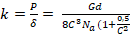 ............................................................................................................(2.2)
2.3 Sistem Harvesting Energy
The output voltage of the piezoelectric material in the form of a series of impulse signals cannot be utilized directly, so a harvesting energy system is needed. Harvesting energy system consists of buck converter, charging module and storage media.

38
Buck converter is a module that functions to convert a DC voltage into a lower DC voltage which has a certain voltage and current (Konuhova et al., 2010). A converter buck is needed to make the input voltage in the form of an impulse into a more continuous DC voltage. One buck converter that can be used is MB39C811. MB39C811 is an integrated circuit which consists of a full-wave bridge rectifier with low loss power. MB39C811 can be applied to harvest energy from piezoelectric which has a small current. The maximum input voltage from an AC source is 24V with a maximum input current of 50mA (Goyal & Palwalia, 2016).

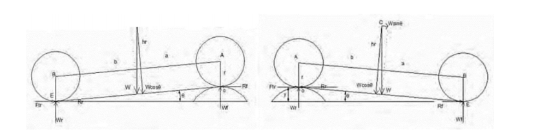

Figures 2. Interaction model between SBEH with front and rear wheel pressures
When the vehicle interacts with the SBEH model, the weight of the vehicle given to the speed bump cover will move vertically downwards.

  - Bluff body
Bluff body is a geometrical structure that functions to separate regular or irregular flow. Streamlined fluid flow that passes through the bluff body will cause the process with high vorticity values ​​so that it allows vortex on the flow. Vortex is a phenomenon measured in streamlines that have large random rotational values. The vortex rotation will make the movement of the affected fluid to be random and Vehicle Mechanical Energy tends to lead to turbulence, if the vortex in the air flow is greater, it can be used as a piezoelectric drive of the cantilever system so that vibrations arise continuously. Illustration of the use of a bluff body as an air flow solver and is applied to the cantilevered piezoelectric system.

III. METODELOGI PENELITIAN

3.1 Modeling the piezoelectric speed bump system
In contrast to conventional speed bumps that provide a fixed height profile, the design of the speed bump based power plant can move up and down and have dynamic interactions with the vehicles that pass through it. By modifying the speed bump so that it can change the kinetic energy and potential speed bump and then converted to electrical energy when moving the generator when the vehicle crosses the speed bump. To simplify the analysis, it is assumed that vehicles passing through speed bumps have a constant speed, thus the horizontal speed of the tire is equal to the speed of the vehicle. The speed of the vehicle is constant when the vehicle passes the speed bump which is 5 km / hour, 10 km / hour and 15 km / hour. A piezoelectric speed bump model can be modeled in a spring mass system. This modeling can be derived into mathematical equations to observe the parameters that affect the piezoelectric output voltage expressed as follows:
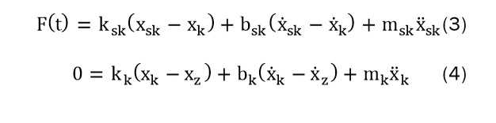


39
In electrical modeling can be modeled by equation (6) which shows the relationship of deflection in piezoelectric to the voltage generated
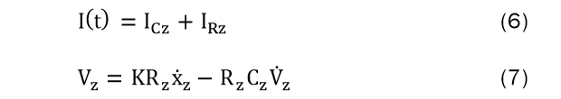
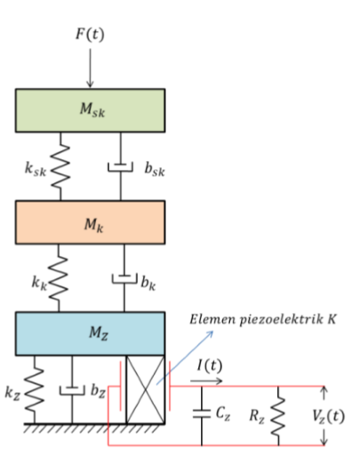
Figures 3. modeling the piezoelectric cantilever system.
Based on the modeling, it can be observed that the parameters that affect the piezoelectric output voltage are deflection or piezoelectric changes ((X_Z) ̇). The larger piezoelectric deflection changes will cause the output current and output voltage to increase. Piezoelectric changes ((X_Z) dipengaruhi) are influenced by factors of KSK, bsk, msk, kk, and mk. This parameter is a parameter that can be changed according to the choice of material when making a piezoelectric cantilever system. The right material selection is needed to produce optimal piezoelectric deflection. Other parameters such as kz, bz, mr, Rz, and Cz are parameters that are fixed according to the piezoelectric type used.

3.2 Design of a piezoelectric speed bump system
The design of the speed bump system includes cantilever design, mechanical speed bump system, and spring design and design by measuring the average electric voltage and the maximum electric voltage generated by the piezoelectric cantilever system in the air flow without bluff body, passing through a triangular bluff body and the circle. The distance between the piezoelectric and bluff body used in this study is 50 and 100 mm. Cantilever design is done by testing the cantilever with input in the form of a 6 Hz frequency shaker using Kinez K7520BP2 piezoelectric. The K7520BP2 piezoelectric material is affixed directly to the cantilever coming from 0.25mm thick stainless steel and 160mm long from the clamp point. Tests carried out include piezoelectric circuit configuration, piezoelectric position at cantilever and determination of cantilever maximum deflection. Piezoelectric configuration testing is done in two ways, namely piezoelectric which is arranged in parallel and in series. The next test is the position of the piezoelectric material in the cantilever. This test is intended to determine the most optimal position of piezoelectric to cantilever.

40

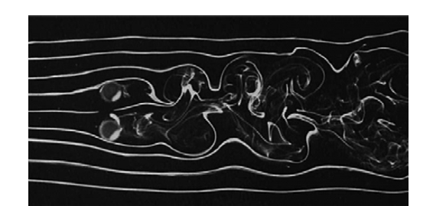
Figures 4. Vortex phenomenon when air passes through a cylindrical cross section
4. RESULTS AND DISCUSSION
4.1 Discussion results Dynamic performance of SBEH simulations
The dynamic performance of SBEH simulations and vehicles that pass speed bump is done with initial conditions with vehicle speeds of 5 km / h, 10 km / h and 15 km / h.

Table 1. Effect of variations in vehicle speed on the speed bump speed response.
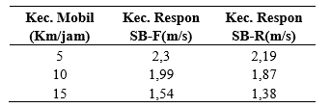
The response of the speed bump down to the variation of changes in vehicle speed is given to the speed bump with the same mass, so the speed down as the response generated by the speed bump will be small. Or in other words, the greater the slower the vehicle that crosses the speed bump with the same mass, the speed decreases as the response generated by the speed bump will be large.

4.2 Test results of cantilever systems.
The Kinez K7520BP2 piezoelectric test, which is arranged in series and parallel, proves that Kinez piezoelectric is only capable of producing electrical voltage when arranged in parallel. This is motivated by the basic characteristics of the polarity and polar arrangement of the material present in Kinez K7520BP2. The piezoelectric position of the cantilever influences the output voltage. Following are the results of testing the piezoelectric position of cantilever.

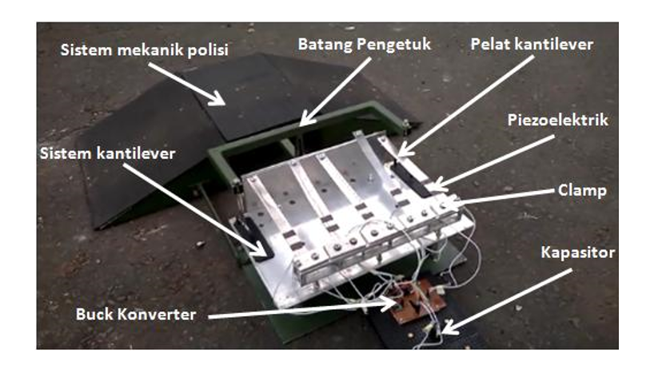

41
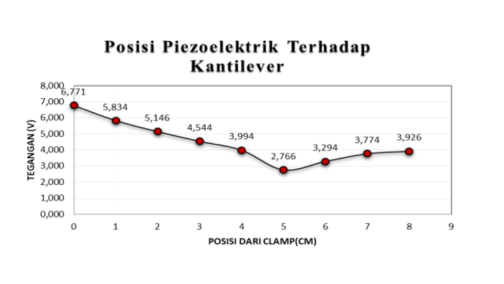
Figures 5. Test results of piezoelectric position on cantilever

Based on the theory, piezoelectric bending will be even greater when it is at point 0 clamp which causes the piezoelectric output voltage to increase. The voltage profile obtained after the test shown in Figure 4 is the same as the theory that when the piezoelectric is near the clamp it is able to produce the greatest voltage. Therefore, in designing the piezoelectric position will be placed close to the clamp to obtain the maximum bend.

4.3 Results of manual testing of piezoelectric cantilever systems
The test of piezoelectric cantilever system is intended to choose the most optimal configuration between piezoelectric and buck converter in producing electrical energy. The configuration used is a piezoelectric circuit using AC1 and AC2 (single piezoelectric circuit) on an MB39C811 and utilizing AC1 (piezoelectric parallel circuit).
The test results show the use of piezoelectric in parallel produces a higher voltage on the 10,000uF capacitor so that in the next design for a piezoelectric system and MB39C811 a parallel circuit is used. After that the system is identified by arranging buck converter in series or in parallel. Parallel buck converter circuits produce higher voltages because the circuit can collect current continuously even though the input is not continuous whereas in series buck series converters often experience open or reduced voltage as a result the inrush current is not continuous. The next test is to test the effect of adding piezoelectric and buck converter systems in parallel to the voltage on the capacitor. The test results show that the more piezoelectricity used, the more energy can be produced. The relationship between the piezoelectric amount and the resulting voltage has a linear relationship as shown in Figures 6 .
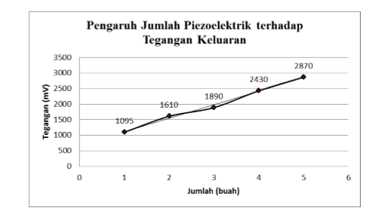
Figures 6. influence of the piezoelectric amount on the output voltage.
4.4. Test results for piezoelectric speed bumps
Testing the cantilever system with a motorized vehicle input using a test car 60 times as much as a runaway on a piezoelectric speed bump. The test can produce electrical energy of 380mV for 1200 seconds with a power of 2,166 mWh.

42
When compared with manual testing with the same conditions that is 60 beats for 300 seconds obtained 1120 mV of electrical energy and 75,264mWh of power. The efficiency of the piezoelectric speed bump system only reaches 2.87%.
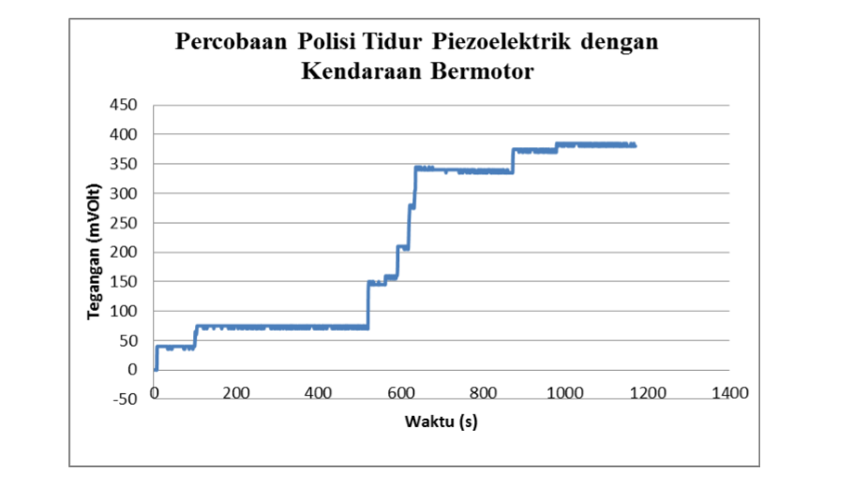
Figures 7. Results of testing a piezoelectric speed bump with a motorized vehicle
This is due to the mechanical energy transmission of the piezoelectric speed bump to the piezoelectric cantilever system that has not been running optimally. The pressure that is not optimal is caused by the rod bumps knocker do not press the piezoelectric cantilever system to the maximum due to the overturn of vehicle tires that are not always right at the center of the mechanics of the bump police. In addition, the mechanical system is not always pressured downwards sometimes the pressure causes the knocker to rise upward. The speed of the car that is not constant also affects the speed bump deflection which causes deflection of the piezoelectric cantilever system is not always the same in every vehicle run over. Limitations of testing also exist in the time it takes for a car to run over the speed bump. The average time lapse of a car to be able to go back and forth running through a speed bump takes 12 seconds. This causes the voltage stored in the capacitor on the MB39C811 to quickly decrease and tend to run out. This is in contrast to manual testing where the piezoelectric cantilever system is always under pressure at an interval of five seconds.

V. CONCLUSION.
From the results of the design research and simulation of this SBEH speed bump model
1. The maximum down speed produced is approximately 2.3 m / s when a vehicle passes the prototype with an average speed of 5 km / hour.
2. The designed piezoelectric bed consists of a speed bump mechanical system, a piezoelectric cantilever system and a buck converter that is capable of producing electrical energy with four-wheeled motorized pressure input. The configuration of a piezoelectric cantilever system that is capable of producing optimal electrical voltage is to use several parallel piezoelectric configurations that are connected with buck converters MB39C811 in parallel. The number of piezoelectric modules and MB39C811 modules influences the amount of energy that can be produced, the more piezoelectric and MB39C811 sets used, the greater the voltage generated but there is an optimal value of the number of piezoelectrics used based on mathematical modeling of the system and the size of the speed bump. The power that can be produced by the piezoelectric speed bump prototype based on testing using a motorized vehicle is 2,166 mWh while with a manual test of 75,264mWh with an efficiency achieved of 2.87% of the manual test, this is because energy transmission has not been carried out optimally.
3. The installation of the bluff body gives rise to a vortex in the airflow so as to increase vibration and electrical voltage on the piezoelectric. The triangular cross body blades have the maximum electric voltage and the highest average voltage due to the high flow velocity and the resulting vortex.

43
REFERENCES
Dzulfikar, D., & Broto, W. (2016). OPTIMALISASI PEMANFAATAN ENERGI LISTRIK TENAGA SURYA Abstrak. V, 73–76.
Goyal, S. K., & Palwalia, D. K. (2016). Analysis of performance parameters and estimation of optimum capacitance for asynchronous generator. Engineering Science and Technology, an International Journal, 19(4), 1753–1762. https://doi.org/10.1016/j.jestch.2016.05.015
Hesari, S., & Sistani, M. B. N. (2017). Efficiency improvement of induction motor using fuzzy-genetic algorithm. 30th Power System Conference, PSC 2015, May 2016, 210–216. https://doi.org/10.1109/IPSC.2015.7827750
Kar, B. N., Mohanty, K. B., & Singh, M. (2011). Indirect vector control of induction motor using fuzzy logic controller. 2011 10th International Conference on Environment and Electrical Engineering, 4, 1–4. https://doi.org/10.1109/EEEIC.2011.5874782
Konuhova, M., Orlovskis, G., & Ketners, K. (2010). Mathematical Modelling of Induction Motor Transient Processes During Stator Winding Interruption. 27, 73–76.
Lubis, A. H. (2018). ICT Usage Amongst Lecturers and Its Impact Towards Learning Process Quality. 34(1), 284–299.
Lubis, S. A., Hariyanto, E., Perangin-angin, M. I., Saputra, S., Niska, D. Y., Wahyuni, S., Nasution, D., & Iqbal, M. (2015). APPLICATION HYBRID ECO CAMPUS VEHICLE BASED ON SOLAR POWER. 3(2).
Melo, P., Castro, R. De, & Esteves Araújo, R. (2012). Evaluation of an Energy Loss-Minimization Algorithm for EVs Based on Induction Motor. In Induction Motors – Modelling and Control (pp. 401–426). https://doi.org/10.5772/52280
Mr. Punit L. Ratnani. (2014). Mathematical Modelling of an 3 Phase Induction Motor Using MATLAB/Simulink\n. Ijmer, 4(6), 62–67. http://www.ijmer.com/papers/Vol4_Issue6/Version-2/IJMER-46026267.pdf
Solly Aryza, Hermansyah, Muhammad Irwanto, Zulkarnain Lubis, A. I. (2017). A NOVELTY OF QUALITY FERTILIZER DRYER BASED ON SOLAR CELL AND ANN. Scopus, 1–5.
solly Aryza. (2017). A Novelty Design Of Minimization Of Electrical Losses In A Vector Controlled Induction Machine Drive. Scopus, 1, 20155.
Waheedabeevi, M., & Sukeshkumar, A. (2012). New online loss- minimization-based control of scalar and vector-controlled induction motor drives. 2012 IEEE International Conference on Power Electronics, Drives and Energy Systems (PEDES), 1–7. https://doi.org/10.1109/PEDES.2012.6484347

44

