INTERPOLATION ALGORITHM IN SOLAR PANEL LIGHT ABSORPTION

Ihsanurrizqie Indra Siregar¹, Rahmad Rizki², Suwarno³, M Fitra⁴

^{1,2}Student Magister Electrical Engineering, Universitas Muhamadiyah Sumatera Utara
³Faculty Electrical Engineering, Institute Tekhnology Medan, North Sumatera
⁴Lecture Magister Electrical Engineering, Universitas Muhammadiyah Sumatera Utara

ABSTRACT
This study describes the increase in light energy that occurs on the surface of the solar panel or photovoltaic (PV) using a sensor distribution where the data is processed by the cubic spline interpolation method so that it can be used to determine the position of the solar panels which are effective and ideal for receiving sunlight. so that you get information about the power released by the solar panels. The mapping of heat distribution on PV panels uses the cubic spline interpolation method, which results from the interpolation and experimental results showing the PV panel in a vertical position with a slope of 0º at 12.00-14.00 produces the highest current, namely 449.2mA with a voltage generated of 1.03V resulting in a power of 0.46W This is more optimal than the PV surface temperature which is hotter in the vertical position with a slope of 45º or the horizontal position of 0º and 45º at the same hour.
Keywords: solar panels, heatmap, cubic spline, interpolation

- INTRODUCTION
The issue of energy is likely to remain an interesting research topic throughout human civilization. Efforts to find alternative energy sources as replacements for fossil fuels are still hotly discussed. There are several natural energy sources available as clean alternative energy, no polluted, safe and in unlimited supply (Khairunnisa et al., 2017) among them is solar energy. In the future, with the greater energy needs, the use of various electrical energy sources seems inevitable.
Therefore, an assessment of various sources new energy will never be a wasted step. Photovoltaic technology which converts direct sunlight into electrical energy with using a semiconductor device called solar cells (Solly Aryza, et al, 2017) many have been studied by previous researchers. On the other hand artificial solar cell panels the factory is also available.
This PV cell will issue electric power according to the light energy received. However, the power released is not evenly distributed due to the heat from the sunlight received is also uneven on the surface of the solar panel .

Also, there is still a suspicion that if the PV is placed in a place where it is exposed to the hot sun, it will produce optimal voltage and electric current, but on the contrary, if the placement of the solar panels is not correct, it will only produce power that is not optimal (Yazidi & Sivert, 2016) .
Some solutions to this problem are by varying the tilt of the solar panels to find the optimal slope of the resulting current and voltage and also tracking the solar panels against the movement of the sun along with monitoring the currents and voltages released by the solar panels (Chandra Mouli et al., 2016). The research only emphasizes the control system so that the solar panels can follow the direction of the sun's movement, but does not monitor how the sun's heat affects the currents emitted by the solar panels. The use of temperature sensors placed on the PV surface to determine the panel surface temperature and its effect on current and voltage output has been carried out by (Jibhakate et al., 2014).

17
Exposure of the PV module to sunlight, the amount of energy from the sun that is converted to useful energy is about 31%, but the percentage of the change is greater to heat energy, which tends to make the module temperature rise, and this causes a reduction in the electric power generated by the PV module (Chandra Mouli et al., 2016). Based on these studies, sufficient heat on the panel surface will result in a large current and voltage output. However, in both studies, it is not known what the distribution or distribution of heat on the PV surface is to the variation of the tilt of the solar panel about voltage and current output.
This study aims to determine the distribution or distribution of heat that occurs on the PV surface with sensor distribution data processed by the cubic spline interpolation method so that it can be used to determine the position of the solar panel which is effective and ideal for receiving sunlight. The ideal that is meant by the author is the power generated by the solar panel itself in varying positions. The position of the solar panel refers to the experiment (Rabanal-Arabach et al., 2015), namely with a 0o or 45o tilt position in a vertical and horizontal position and an open field and perpendicular to the cardinal directions of the East. The sensor will capture the temperature at a predetermined point, then the data is sent to the webserver periodically. After the data is sent to the server, a PV surface heat distribution map will be created.

- LITERATURE REVIEW.

  - Power and Energy

When the charge passes through the circuit element the electric field acts on the payload. The total work done on charge q through the circuit the element is proportional to the product q and the potential difference V. If the currents are I and time interval dt, then the amount of charge flowing is dQ = I s. That effort work on this charge are (Lubis et al., 2015):

dw = VdQ = VIdt ……………................……….. (1)

18

This work shows the electrical energy transferred into the elements Suite. The energy transfer per unit of time is called the power indicated by P. Dividing equation 2.1 above by dt will get the speed of delivery energy in the circuit namely
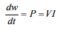...............................................(2)

The units for V are volts or joules per coulomb and the unit for I is amperes or coulomb per second, so the unit of P is J / s (watts):

  - Daily Sun Radiation on Earth's Surface.
Solar radiation that is available outside the Earth's atmosphere or is often called solar radiation constant of 1353 W / m2 reduced by the intensity absorption and reflection by the atmosphere before reaching the earth's surface. Ozone in the atmosphere absorbs short-wavelength (ultraviolet) radiation whereas carbon dioxide and water vapor absorb some of the radiation with a longer wave length (infrared). In addition to the reduction in Earth's radiation directly or highlighted by the absorption, there is still radiation that is emitted gas, dust, and water vapor molecules in the atmosphere before reaching Earth which is referred to as scattered radiation as shown in Figure 1 (Goyal & Palwalia, 2016).

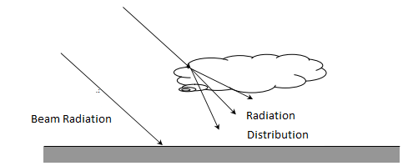
Figure 1. Spot radiation and scattered radiation that hit
surface of the earth

With the above factors cause the radiation received Earth's surface has a different intensity every time.

  - Interpolation
There are several interpolation formulas, including Newton's divided differentiation interpolation, Lagrange interpolation, and spline interpolation. Newton divided differentiation interpolation is further divided into linear interpolation and quadratic interpolation. In this paper, the linear interpolation method will be applied to image magnification. Linear interpolation is a first-order polynomial and passes through a straight line at each of the two successive input points. The two input points are used to estimate intermediate prices between the correct data points. The method most often used for this purpose is a polynomial interpolation.
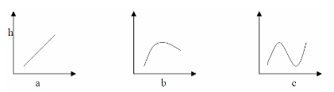

Figures 2. Examples of interpolated polynomials: a. First order (linear) connects 2 points; b. Second order (quadratic or parabola) connecting 3 points; c. Third order (cubic) connecting 4 points.

For n + 1 data points, there is one and only one polynomial of nth order or less that passes through all the points. For example, there is only one straight line (ie first-order polynomial) connecting the two points as shown in Figure 1.a above. In the same way, only one parabola connects the collection of 3 dots. This polynomial interpolation then provides a formula for calculating the intermediate values

III. METHOD OF RESEARCH

Cubic Interpolation The heatmap is a distribution map generated by the two-dimensional interpolation method, in this case, the temperature distribution map of the sensor that has been placed on the PV surface.

19
In this paper, heat distribution mapping has carried out using linear interpolation techniques. Interpolation in this case is to calculate the temperature between two sensor points.
The purpose of this interpolation is to minimize costs because there is no need for many sensors to be used only for a few points. In this case, the temperature distribution will be done with a cubic spline. Heatmaps are also created by grouping data, heatmap grouping consists of rows and columns to form matrix data.
The data matrix contains temperature data obtained by the temperature sensor. Then the sensor data will be classified into color. The hotter the temperature, the resulting color will be redder, besides that, if the temperature gets colder, the color will be more inclined towards blue. Cubic spline interpolation is an interpolation that has higher precision compared to other interpolations, this is because the neighboring order used by this interpolation is three.
The values ​​of this order will later be used on the shading nodes that appear to exist on the solar panel. The following are general cubic spline equations that are used:

f(x)=x3+x2-3x-3=0...............................(3)

From Equation (1) above, it can be concluded that the cubic spline method is to divide the function interval into subintervals where each sub-interval will look for the values ​​a, b, c, and d, after which it will be combined into a complete polynomial equation. where the value of x is the temperature data that has been stored in the database. After these values ​​are known, next is that we can find out what the estimated temperature value is in the vicinity of the sensor. The following is the difference in the results of the heat map using cubic spline interpolation with other interpolation methods .
This research continues previous research (Saputra, Erfianto, Saputra, Prabowo, & Swastika, 2019). This study uses similar research to the author, but in the journal uses a linear interpolation technique,

while the authors of this study use a cubic spline interpolation technique where the technique has a better level of precision.
The use of the DS18B20 temperature sensor refers to (Saputra, Erfianto, Saputra, Prabowo, & Swastika, 2019). As for the selection of the INA219 voltage and current sensor, it refers to
the journal (Cholish & Sara, 2016) because this sensor can calculate current and voltage simultaneously. The use of the DS18B20 temperature sensor is because this sensor.
Linear Interpolation to Map Heat Distribution on the Surface of Solar Cell Panels, cubic-spline, because based on the open-source Python organization (Zhao, Guo, Sheng, & Shyr, 2014) explains that the algorithm is better than other heatmap making algorithms.

Tables 1. Solar radiation data for the year from 2018
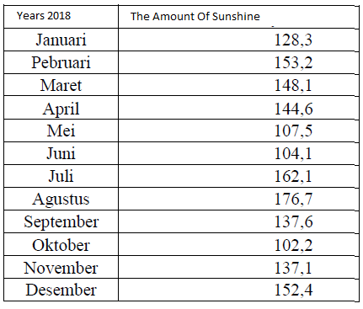

Noted: that x is the number of months, f (x) is the length of the sunshine

IV. RESULTS

Based on the results of experiments conducted that the ideal slope for the installation of solar panels is 45o and also 0o with a slope to the west. The purpose of this ideal is the position of the solar panels that produce the most power compared to other scenarios. It is also done in a vertical and horizontal position for each slope.

20
Figures 3. Testing and Experiment

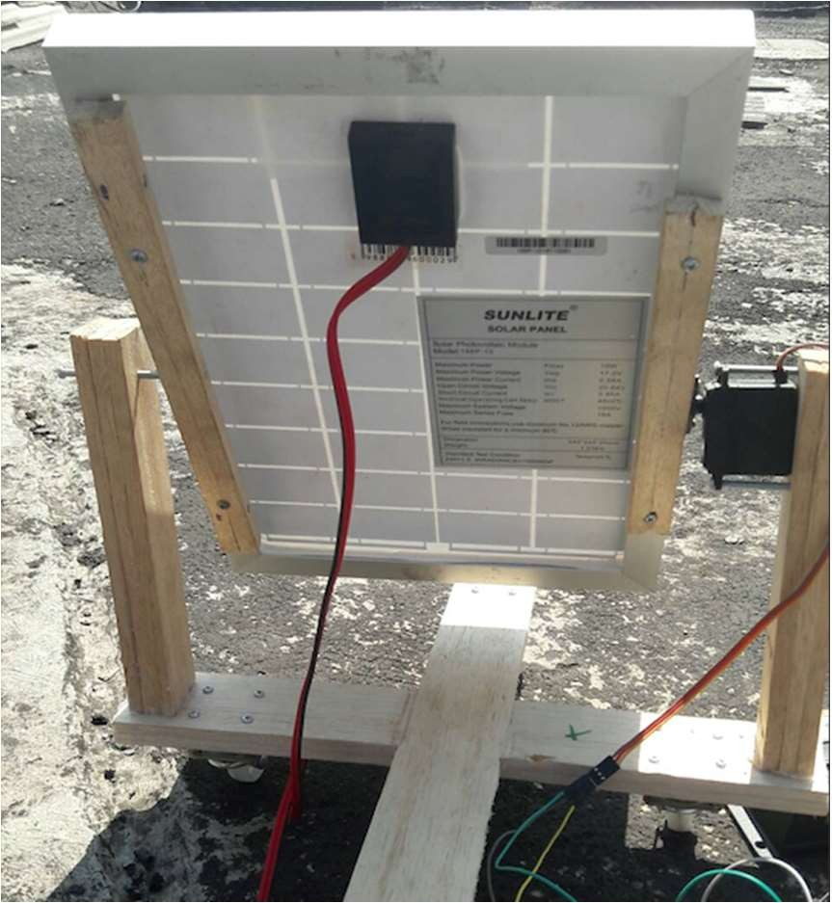
The tilt of the solar panels towards the ground certainly affects the sun's heat on the surface of the solar panels because the sun's heat from noon to the afternoon is hotter than from morning to noon. The vertical and horizontal installation also affects the power released by the solar panels, this is because when the sun's rays move from east to west in a vertical position on the top of the surface of the solar panel while in a horizontal position it will hit the side of the solar panel.
Of course, this will differentiate the power generated by solar panels. The illustrative example of panel installation during the experiment can be seen in Figure 3. The following is the scenario carried out in this study:
1. 0o slope with a horizontal position.
2. 0o inclination with vertical position.
3. Slope of 45o with a vertical position to the west.
4. Slope of 45o with a horizontal position to the west.

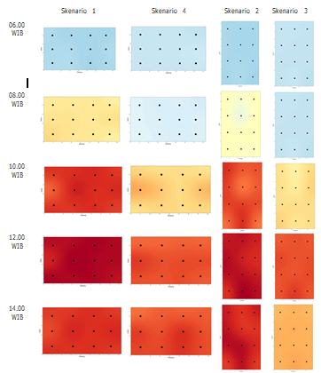

Description Temperature :

Figures 4. temperature distribution in sollar panels

Tables 2. Result Experiment
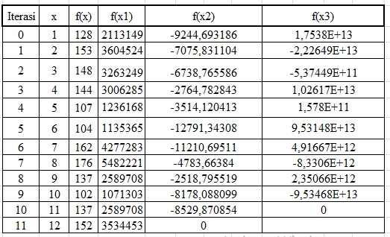

In the experiment, it can be seen that the highest voltage obtained in scenario one is 1.04V at 06.00 to 10.00, in scenario two is 1.04V at 08.00 to 10.00, in scenario three is 1.04V at 06.00 to 08.00 and also from 12.00 to 14.00, and in scenario four it is 1.07 at 08.00. The difference in output voltage generated by solar panels is caused by the influence of temperature on the surface of the solar panel. This can be confirmed by the interpolated heat map results in experiment 1 and experiment 4 (see Figure 4) at 12.00 to 14.00 where the interpolated heatmaps of the PV surface in experiment one show hotter results (dark red) with even heat distribution on the PV surface. Thus, the voltage generated in experiment 1 is lower than experiment 4. The voltage drop due to sun heat exposure also applies to experiment 2 with the PV position held vertically.

From these experiments a heat map has been generated with a pixel size of 1239x731 for the horizontal position and 911x1545 for the vertical position. Based on the experiments that have been carried out as well as the heatmapholation results of the interpolation in Figure 3, it can be concluded that the ideal position for placing the PV panel is in a vertical position with a slope of 0o (Scenario 2) and the optimal current generated at 12.00 is 449.2 mA and produces a voltage of 1.03 V.

Besides that, in the experimental scenario it can also be concluded that PV cannot transmit power in the morning at 06.00 WIB and also in the evening at 18.00 WIB, this is because there is no sunlight that exposes the surface of the PV panel.

V. CONCLUSION
In this research, a linear spline interpolation method has been developed to interpolate PV panel surface temperature data and visualize it in a distribution map. Color visualization on the heatmap represents temperature data on the PV surface. This interpolation technique also allows for smoother visualization of the heatmap and if there are more sensor points, the more accurate the interpolation and visualization results will be. This research uses 12 thermal sensor points that are placed on a 10WP PV panel. In this research, the measurement of the current and output voltage of PV was also carried out. This is more optimal than the hotter PV surface temperature in scenario 1 and scenario 4 at the same hour. Therefore, a better position for the application of solar panels is like scenario 2. For further development, you can use solar panels with a size of 10WP equipped with the ability of a solar tracker to adjust to the movement of the sun. In addition, the system built can be connected to the internet so that users can find out the power produced every day and how much power is stored in the battery.

REFERENCES
Chandra Mouli, G. R., Bauer, P., & Zeman, M. (2016). System design for a solar powered electric vehicle charging station for workplaces. Applied Energy, 168, 434–443. https://doi.org/10.1016/j.apenergy.2016.01.110
Goyal, S. K., & Palwalia, D. K. (2016). Analysis of performance parameters and estimation of optimum capacitance for asynchronous generator. Engineering Science and Technology, an International Journal, 19(4), 1753–1762. https://doi.org/10.1016/j.jestch.2016.05.015

21
Jibhakate, C. N., Prof, A., & Huchche, V. (2014). Speed Control of Single Phase Induction Motor Using Micro- Controller. Speed Control of Single Phase Induction Motor Using TRIAC, 9359(April), 29–32.
Khairunnisa, I., Suprayogi, & Tri Ayodha Ajiwiguna. (2017). Pemanfaatan Modul Termoelektrik Sebagai Pemanas Untuk Alat Penetas Telur Sederhana. E-Proceeding of Engineering, 4(1), 769–777.
Lubis, S. A., Hariyanto, E., Perangin-angin, M. I., Saputra, S., Niska, D. Y., Wahyuni, S., Nasution, D., & Iqbal, M. (2015). APPLICATION HYBRID ECO CAMPUS VEHICLE BASED ON SOLAR POWER. 3(2).
Rabanal-Arabach, J., Schneider, A., & Cabrera, E. (2015). Minimization of Electrical Losses of PV Modules Located in Places with High Solar Irradiance. Energy Procedia, 77, 402–406. https://doi.org/10.1016/j.egypro.2015.07.056
Solly Aryza, Hermansyah, Muhammad Irwanto, Zulkarnain Lubis, A. I. (2017). A NOVELTY OF QUALITY FERTILIZER DRYER BASED ON SOLAR CELL AND ANN. Scopus, 1–5.
Yazidi, A., & Sivert, A. (2016). FUZZY LOGIC CONTROL DESIGN FOR. 7(3), 14–24.

22

