ENHANCEMENT OF EMPLOYEE PERFORMANCE THROUGH QUALITY OF TECHNICAL ACADEMY AND SAFETY OF MEDAN AVIATION
Susi Diriyanti Novalina¹, Rossi Peter Simanjuntak², Darmeli Nasution³
Academy Of Engineering Techniques And Safety
Medan North Sumatera, Indonesia

ABSTRACT
This study aims to determine the effect of employee performance on the implementation of promotions position in the Department of Youth and Sports in Medan City. This research uses a quantitative approach with survey research methods, namely research that takes samples from a population and uses the questionnaire as a primary data collection tool. The population of this research is all employees who work in the Medan Youth and Sports Agency. A number of samples used as many as 63 respondents. The results showed that employee performance has a significant effect positive about the promotion of the position, meaning that if the employee's performance is good then the employee can get a promotion. Thus the hypothesis that there is an influence on employee performance for promotion is acceptable.
Keywords: Employee performance, and promotion

I. INTRODUCTION.
In the last decade, quality awareness has made people demand the minimum standards of service they use to prove that the organizations that provide these services can be trusted. To answer these challenges, organizations implement a Quality Management System (QMS). The application of the QMS confirms that the fulfillment of product or service requirements can be affected directly or indirectly by the work of the work implementer (Br Purba, 2017).
This performance is a combination of three important factors namely the ability and interest of a worker, the ability and acceptance of the delegation's explanation of the task and participation, and the level of motivation of the worker concerned. The higher these three factors, the greater the performance of employees (Hasibuan, 2005). This study uses quality management system factors in influencing employee performance because so far the Medan Aviation Engineering and Safety Academy has implemented a quality management system. The Quality Management System is an international standard that regulates the quality management system, both in setting policies and quality objectives and the achievement that can be applied in every type of organization/company. Initially, this Quality Management System was only implemented by private companies, because ISO 9001: 2008 was oriented towards consumers or customers (Atmadja et al., 2015). However, in recent years, many government agencies also want to gain recognition of the quality of their management through implementation. The demand for good governance is the reason for many government agencies to obtain certificates, bearing in mind the quality management principles contained in are part of good governance. Besides, these principles also contain elements of internal control for an organization (Tarigan et al., 2018).
As one of the Higher Education Institutions oriented to produce quality human resources is required to implement a Quality Management System so that it is expected that an increase in employee performance at the Medan Aviation Engineering and Safety Academy (Waterfront & Centre, 2017).
Some Types of Certification that have been owned by the Medan Aviation Engineering and Safety Academy include: Approved Training Center, Airport Electric Personnel, ISO 9000: 2015, BAN PT Certificate and others. The implementation of ISO will have a positive impact on performance if supported by a culture of good quality. The core values ​​of the organization will be held intensively and widely embraced in a strong culture. A strong culture shows a high level of agreement among members about what must be maintained by the organization. An understanding of organizational culture for employees will foster cohesiveness, loyalty and organizational commitment.

28
The problems seen by the Medan Aviation Engineering and Safety Academy related to employee performance include the presence of several employees who have not been able to achieve the work targets, in addition to that there are also indicators of employee performance achievements that have not been maximized so that their performance is not good enough. Following are the data regarding the performance evaluation of Medan Aviation Engineering and Safety Academy employees (Adha Inapty & Martiningsih, 2016).

II. LITERATUR REVIEW.

In carrying out their work, employees produce something called performance. Performance is the result of a person's work during a certain period compared to various possibilities such as standards, targets/targets, or criteria that have been determined in advance and agreed upon together. Mangkunegara (2009) states that: "Performance is the work of quality and quantity achieved by an employee in carrying out their duties in accordance with the responsibilities given to him." While Hasibuan (2005) states that: "Performance is a work that is achieved by someone in carrying out the tasks assigned to him based on skill, experience, and sincerity as well as time. " According to the above understanding, performance is equated with the work of an employee. To achieve good performance, the most dominant element is human resources, although the planning has been well structured and neat, if the person or personnel who carry out are not qualified and do not have high morale, then the plan that has been prepared will be in vain (Li et al., 2016)
.
2.1. The Important Role of Performance.
Performance management is the process of consolidating goal setting, performance appraisal, and development into a single shared system, the aim of which is to ensure that employee performance supports the company's strategic objectives (Umar et al., 2018). Performance management includes practices where managers define employee goals and work, develop employee capabilities, and evaluate and give rewards to one's businesses. High employee performance is needed in an organization because the creation of high employee performance will affect professional work situations. Performance management as a process to create a common understanding of what must be achieved and the management of employees so as to increase the likelihood of achieving goals. Performance refers to the level of success in carrying out the task and the ability to achieve the goals set. The performance is declared good and successful if the desired goals can be achieved properly. Almost all companies have both formal and informal assessment tools to assess the performance of their employees. Performance appraisal means evaluating current and / or employee performance in the past relative to performance standards (Aryza et al., 2011).
Thus, performance is a function of motivation and ability. To complete a task or job, a person must have a degree of willingness and ability level (Febtiwiyanti & Sidopekso, 2016).

2.2. Factors That Affect Performance
Many factors affect the performance of an employee. Factors that influence the achievement of good performance. Factors that affect performance according to the company, in general, to move employees from one job to another are considered or parallel to be influenced by various factors, both related to the workforce itself. The quality management system consists of the process of identifying, encouraging, measuring, evaluating, improving, and rewarding employee performance (Rahadi, 2010). As seen in Figure 2.1. Quality management links organizational strategy to performance results.

29
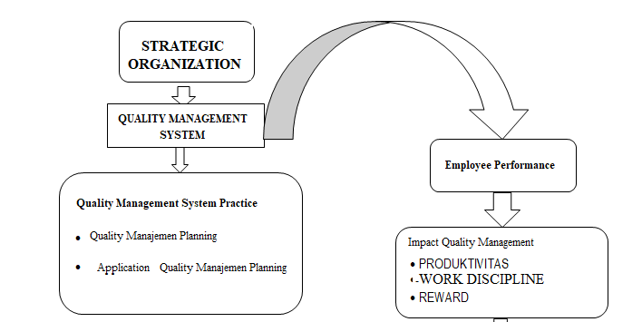
Figure 1. Quality Organization
2.3. Performance Indicator
Performance indicators must be identified based on a form of measurement that will assess the results and outcomes obtained from the activities carried out in order to achieve the strategic goals and objectives of the organization. Mangkunegara (2009), states that employee performance indicators, namely:
1. Quality of work. Reflect improvement in quality and work standards that have been predetermined, usually accompanied by an increase in the ability and economic value.
2. Work quantity Reflecting the increase in volume or amount of an activity unit that produces goods in terms of quantity. The quantity of work can be measured through the addition of physical values ​​and goods from previous results.
3. Can not be relied upon Reflecting how a person completes a job that is given to him with a high level of accuracy, willingness and enthusiasm.
4. Cooperative attitude Reflecting the attitude that shows the high level of cooperation between each other and the attitude towards superiors, also towards employees of other companies.

2.4. Position, Principal Duties And Functions Of ATKP Field
As an educational institution, ATKP Medan has the following positions, duties, and functions:
The Medan Aviation Engineering and Safety Academy, hereinafter abbreviated as ATKP Medan, is an official tertiary institution within the Ministry of Transportation, led by the Director who is below and is responsible to the Head of the Transportation Education and Training Agency. Medan daily ATKP is administratively fostered by the Minister of National Education and technical and operational guidance is carried out by the Minister of Transportation. The development of the Medan ATKP is technically academically carried out by the Minister of National Education as well as the operational technical and competency guidance carried out by the Minister of Transportation. Duty The task of ATKP Medan is to carry out professional education diploma programs in the fields of Aviation Engineering and Aviation Safety. At present most of the students at ATKP Medan from the Radio Engineering and Electrical Engineering Study Program at the Airport, with the ATC Simulator Medan ATKP conducting a Flight Safety Study Program, specifically the Air Traffic Study Program. Function The functions of the ATKP Medan include: Implementing and developing professional education which includes teaching, training, and coaching.

30
Carry out research and community service. Manage libraries, laboratories, simulators, other inscriptions. Fostering the Academic Community and its relationship with the environment. Managing general administration, academic administration, and administration of personnel.

III. ANALYZE AND RESULT
Descriptive statistics in this study summarize and provide an overall picture of the respondents' answers on each item statement used in measuring each research variable. Each statement item is measured using five categories of answers related to the respondent's agreement on the statement given. The variables in this study are SMM Planning, SMM Procedures, Quality Culture and employee performance at Medan Academy of Engineering and Safety. Descriptive statistics of the study are only intended to explain the answers of research respondents and are not to be generalized. Descriptive statistics of the study were tabulated based on answers from all respondents to each item in the questionnaire and a summary of the answers was obtained which was further categorized in conclusion groups based on the mean value of the respondents' answers. The grouping is divided as in Table below:
Table 1. Categorizing the Average Value of Respondents' Answers
Average Value  (Mean) | Categories | Conclusion Answer | Concluison Variable
1,00 – 1,80 | E | Strongly Disagree | Very Bad
1,81 – 2,60 | D | Disagree | Bad
2,61 – 3,40 | C | Not Agree | Enough
3,41 – 4,20 | B | Agree | Good
4,21 – 5,00 | A | Very Agree | Very Good

3.1. Normality Test
Data normality test is very important in parametric statistical analysis so that the regression model is free from prediction errors. SPSS Test Results for data normality can be seen as follows:
Table 2. Test Normality with Kolmogorov-Smirnov One-Sample One-Sample Kolmogorov-Smirnov Test
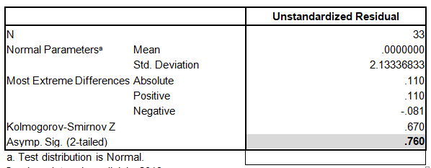
From the results of data processing in table 4.10 above, it can be seen that the significance value of Kolmogorov-Smirnov (K-S) is 0.760, so it can be concluded that the variable data is normally distributed because the significance is> 0.05. Testing the normality of the data can also be determined by looking at the graphical images and the normal distribution curve. The data will be normally distributed if the expected probability value is equal to the expected probability value and the observed probability is shown by a diagonal line which is the intersection between the expectation probability line and the probability of observation.

31
The following is a test of the normality of data results in the form of histogram charts and P-P Plots curves as shown in Figure 2 below:
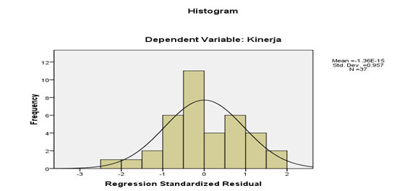
Figures 2. Chart Histogram
Based on the histogram graph in Figure.2 it can be concluded that the data has been normally distributed. This can be seen in the data that follows a diagonal line forming a bell in the middle.
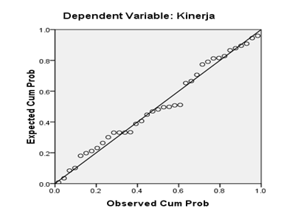
Figures 3. The Curve P-P
Based on the PP-Plos curve in Figure 4.3 it can be concluded that the curve has been distributed normally. This can be seen in the normal PP-Plots curve, where the points spread close to the diagonal line.
3.2. Heterokedasticity Test
Heteroscedasticity test aims to test the occurrence of differences in residual variance of one observation period to another. Heteroscedasticity analysis using scatterplot test graphs. Heteroscedasticity can be done by observing certain patterns on scatterplot charts, where if there are points that spread above and below the number 0 on the Y axis and do not form a pattern then there is no heteroscedasticity. Scatterplot charts can be seen in the following image:

32
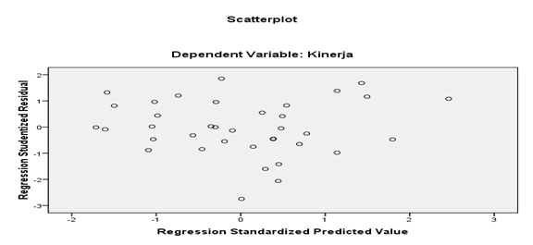
Figures 4. test plot graph
From the scatterplot picture above, it is seen that the points spread randomly and do not form certain patterns or are irregular. This indicates there is no heteroscedasticity in the regression model so that the regression model is feasible to use.

IV. CONCLUSION
Based on the results of this study it can be concluded as follows:
1. SMM Planning has a positive and significant effect on the Culture of Employee Quality at the Medan Aviation Engineering and Safety Academy
2. The QMS procedure has a positive and significant effect on the Culture of Employee Quality at the Medan Aviation Engineering and Safety Academy
3. Quality culture has a positive and not significant effect on employee performance at the Medan Aviation Engineering and Safety Academy
4. SMM planning has a positive and significant effect on employee performance at the Medan Aviation Engineering and Safety Academy
5. SMM Procedures Have a Positive and Significant Impact on Employee Performance at the Medan Aviation Engineering and Safety Academy
6. SMM Planning has a positive and significant effect on performance through the Culture of Employee Quality at the Medan Aviation Engineering and Safety Academy
7. The QMS procedure has a positive and significant effect on performance through the Quality Culture of employees at the Medan Aviation Engineering and Safety Academy

REFERENCES
Adha Inapty, M. A. F. B., & Martiningsih, R. S. P. (2016). PENGARUH PENERAPAN STANDAR AKUNTANSI PEMERINTAH, KOMPETENSI APARATUR DAN PERAN AUDIT INTERNAL TERHADAP KUALITAS INFORMASI LAPORAN KEUANGAN DENGAN SISTEM PENGENDALIAN INTERN SEBAGAI VARIABEL MODERATING (Studi Empiris pada SKPD di Pemprov NTB). Akuntabilitas, 9(1), 27–42. https://doi.org/10.15408/akt.v9i1.3583
Aryza, S., Abdalla, A. N., Khalidin, Z., & Lubis, Z. (2011). Adaptive speed estimation of induction motor based on neural network inverse control. Procedia Engineering, 15. https://doi.org/10.1016/j.proeng.2011.08.786
Atmadja, A. T., Adi, K., & Saputra, K. (2015). Universitas Pendidikan Ganesha , Bali , Indonesia OF VILLAGE FINANCES. 1, 7–16.
Br Purba, R. (2017). Capacity Apparatus Improvement in Managing Economics and Finance towards Independent Village. IOSR Journal of Economics and Finance Ver. I, 8(1), 2321–5933. https://doi.org/10.9790/5933-0801012731

33
Febtiwiyanti, A. E., & Sidopekso, S. (2016). Studi Peningkatan Output Modul Surya dengan menggunakan Reflektor. Jurnal Fisika Dan Aplikasinya, 6(2), 100202. https://doi.org/10.12962/j24604682.v6i2.919
Li, Z., Shang, C., & Shen, Q. (2016). Fuzzy-clustering embedded regression for predicting student academic performance. 2016 IEEE International Conference on Fuzzy Systems, FUZZ-IEEE 2016, 344–351. https://doi.org/10.1109/FUZZ-IEEE.2016.7737707
Tarigan, I. J., Alamsyah, B., Aryza, S., Siahaan, A. P. U., & Isa Indrawan, M. (2018). Crime aspect of telemedicine on health technology. International Journal of Civil Engineering and Technology, 9(10).
Umar, H., Usman, S., & Purba, R. B. (2018). The Influence of Internal Control And Competence of Human Resources on Village Fund Management and The Implications on The Quality of Village Financial Reports. In International Journal of Civil Engineering and Technology (IJCIET) (Vol. 9, Issue 7, pp. 1523–1531).
Waterfront, S., & Centre, C. (2017). Resilience 2017 ( Resilience 2017 ). Resilience 2017, 2017(Resilience), 0–10. www.resilience2017.org

34

