Enhance Parameter Speed Estimation of Induction Motor Using Modified Voltage Model Flux Estimation

Zulkarnain Lubis¹, Solly Aryza², Zulkeflee Khalidin³, Ahmed N Abdallah⁴,
¹Faculty Electrical and Electronic Engineering, Institute Tekhnologi Medan
² Faculty Sains and Technologi, Universitas Pembangunan Panca Budi
³¹Faculty Electrical and Electronic Engineering, University Malaysia Pahang
sollyaryzalubis@gmail.com, zulkeflee@ump.edu.my, ahmed@ump.edu.my

ABSTRACT
Speed estimation in field-oriented vector control of induction motor depends on effective estimation of rotor flux. This paper proposes speed estimator using improved rotor flux estimator based on modified voltage model with a high orders low-pass filter (LPF) and a low-pass filter in series and an error compensator by rotor flux oriented current model. The mathematical model of the motor is based on the use of linear and quadratic equations, reducing therefore the system nonlinearity to at most second degree. The parameter estimation methodology allows the motor model identification using the slip-torque and slip-current motor characteristic. The estimation procedure is demonstrated with some simple numerical examples.
Keywords—Induction Motor, Speed, estimation

Introduction
This paper addresses the issue of induction motor modeling and model estimation for power system analysis studies. Load modeling in power systems is of great importance, for both steady-state and dynamic analysis, and has been addressed extensively in literature [1-8]. Induction motors constitute the most significant part of industrial load and their performance has a considerable impact on the behavior of a power system. [7-15]. In order to obtain the speed information, speed transducers, such as shaft mounted tachogenerator or digital shaft position encoders are used, which degrade the system’s reliability, especially in hostile environments. A speed sensor is an inconvenient device and has many drawbacks. The most important one is reducing the ruggedness and the simplicity of ac motors. It is also a cost factor, since the provision of a special motor- shaft extension to mount the encoder leads to more expensive machines. The use of delicate optical encoders lowers the system reliability, especially in a hostile environment. Because of these problems, it is an important requirement to eliminate the speed sensor from the control systems. Thus, from the beginning of the 1980s, there were serious research works throughout the world to control induction machines without the need for speed sensors [2- 3].
In many of these cases high accuracy is required in the parameter determination, when the problem is viewed from the electric machinery point of view [9]–[16]. However, when load modeling is concerned for power system analysis applications (like load flow analysis, stability analysis, dynamic simulation or power system protection coordination) the level of accuracy needed is considerably less, of the order of 10-15% [17],[25]. Field measurements after specific tests can be used for accurate motor model estimation, however such test are usually difficult or impossible to perform in actual, operational industrial motors [18]–[19]. Furthermore, performing such tests makes little sense when the accuracy requirements are relatively low. The authors append a fifth state (speed) to the motor equations and use an EKF to observe it. Signal injection methods [9-11] use high frequency signals and motor saliency to accurately detect speed over wide ranges. Sliding mode observers [12-14] use the estimated speed to correct a flux-current observer; the correction is based on a sliding mode surface that combines the current error with flux estimation. All known speed estimators depend on the estimation of rotor flux. Accurate estimation of rotor flux is critical for speed estimation especially in the lower speed range.

30
This paper concentrates on the implementation of an induction motor parameter estimation algorithm that is based on numerical solution techniques. The algorithm is implemented based on the state of the art nonlinear least squares numerical solution techniques. The proposed algorithm is applied to the described induction motor models and estimates the model rotor parameters using the slip-torque motor characteristic.
For the estimation of all the motor equivalent circuit parameters the slip-torque characteristic alone is not enough and the slip-current characteristic or the slip-power factor characteristic can be additionally used, to provide extra information. Such characteristics can be most of the times obtained by the manufacturers. Here the characteristics are assumed to be known as a number of discrete points.

MOTOR PARAMETER ESTIMATION
The estimation methodology makes use of data that, in general, can become available from the motor manufacturer, or are easily measured, like the slip-torque characteristic, or the slip-current or slip-power factor characteristics. A parameter estimation procedure becomes even more important, when a slip-dependent parameter model is used. In this case, the model coefficients of equations (1) are difficult of impossible to be evaluated without the use of an estimation procedure.
When the rotor circuit parameters are to be estimated, assuming that the stator and core parameters are known, the slip-torque characteristic of the motor provides adequate information. However, when all the equivalent circuit parameters are to be estimated (6 in total if constant rotor parameters are assumed and 9 if slip-dependent rotor parameters are used), the slip-torque characteristic itself is not enough and some additional information is necessary. Such information can be provided using, for example, the slip current characteristic of the motor along with the slip-torque curve. In this paper the estimation problem will be formulated in its general form, assuming that all the equivalent circuit parameters are to be estimated. The parameters estimation problem can be formulated as a least squares optimization problem, the objective being the minimization of the deviation between the measured torque and current curves and the model generated curves. These curves are known as a set of discrete measurement points.
The mathematical problem formulation is as follows:

min $(J_{\text{eq}}s+B_{m})\text{.}ω_{m}(t)=T_{\text{em}}(t)−T_{L}(t)$ (1)
These equations are used in the estimation procedure because the motor curves and thus the measurement data are obtained under nominal operating conditions. Therefore the estimation is performed under nominal conditions.

VOLTAGE MODEL COMPENSATED BY ROTOR FLUX ORIENTED CURRENT MODEL
The proposed speed estimator is using a stand estimation method. Synchronous frequency is first calculated as:
$ω_{m}(s)=\frac{T_{\text{em}}(s)}{(J_{\text{eq}}s+B_{m})}=\frac{n_{p}\text{.}L_{m}(λ_{\text{rd}}\text{.}i_{\text{sq}}(s)−λ_{\text{rq}}\text{.}i_{\text{sd}}(s))}{L_{r}\text{.}(J_{\text{eq}}s+B_{m})}$ (2)

the expressions for the rotor flux linkage in the stationary reference frame can be obtained by using the stator voltage equations as follow:
$\begin{aligned}K_{V}=\underset{s→0}{\text{lim}}\text{sG}(s)=\frac{\text{435}\text{.}8K_{P}}{\text{21}\text{.}\text{79}} \\ =\text{20 }K_{P}\end{aligned}$ (3)
speed, stator resistance, rotor inductance, magnetizing inductance, rotor flux, rotor time constant, leakage coefficient. The proposed speed estimator using modified voltage model is easier to realize than above analyzed method and is sufficiently robust. The accuracy of speed estimation depends on the accuracy of rotor flux estimation. So we use using modified voltage model rotor flux estimation can improve the accuracy of rotor speed estimation. A description of rotor flux estimator based on modified voltage model and its analysis has been presented in the next section. The model supports two mechanical loading modes: (a)Torque equilibrium, and (b) Constant Slip. In the torque equilibrium mode, the mechanical torque can be either constant, or depend linearly or quadratic ally on the rotational speed.
A model with slip dependent rotor parameters can adequately represent, in a unified way, motors of every type and every NEMA design (A, B, C or D), including motors with double cage, or deep bar rotors. Designs A and D can be accurately represented using constant parameter models; for designs B and C the slip-depended model is used for more realistic representation. Augmentation of the model with the swing equation of the rotor motion allows its usage for quasi-steady state analysis and stability studies [26-28].

31
Based on the analysis of existing voltage model [4], a Renew voltage model with high orders LPF which can remove the DC offset input of Back EMF and a low-pass filter (LPF) which can compensate amplitude and phase errors by rotor flux oriented current model is proposed to replace the existing voltage model. The modified voltage model can suit various conditions. With the time phase method, error compensation is derived, which makes it simpler and easier for the modified voltage model to be applied
to the digital control system. It is chiefly modified in the Back- EMF online zero drift correction and the compensation of rotor flux. The proposed the modified voltage model is shown in Fig 1.
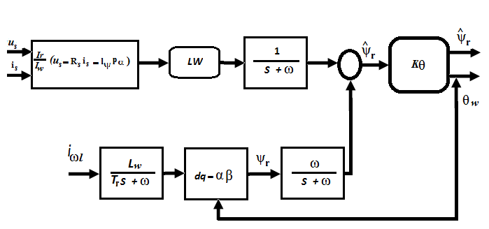
- propoesed voltage model

Simulation result and discussion
The estimation procedure is demonstrated using models that correspond to the four different NEMA designs. The slip torque characteristic is generated using some specific parameters and then these curves are used as input to the estimation algorithm. The estimated values are compared with the actual values, which in this artificial example are known. Without loss of generality, the presented examples assume that only the rotor circuit parameters are to be estimated, while the stator and core parameters are known. Therefore, only the slip torque characteristic will be used as set of measurements. Such a situation may arise, for example, if a slip-dependent model is used and needs to be identified. In all cases the estimation algorithm provided practically exact values of the model parameters. For the motors A, B and D the simple Gauss-Newton based algorithm without global convergence strategy was enough. In the case of motor C, the simple Gauss-Newton algorithm and the line search failed to provide the solution, therefore the trust region algorithm was employed, as a global convergence strategy, along with the Gauss-Newton solution process to provide a result.
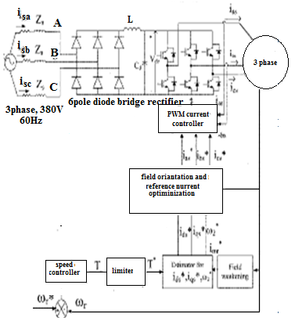
- Induction motor use modified Voltage model Flux estimation
32

The machine parameters used in this study shown in Table 1.
Table1. Induction machines Parameter
380 V | 10A | 5 kW
Ls=Lr=0.4 H | Lm= 0.372H | 1628r/min
Rs= 2.5ohm | Rr= 1.9 ohm | 6 poles

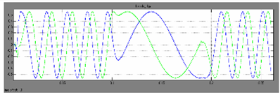
- Estimatied Stator flux
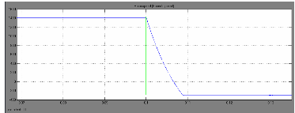
- Speed of modified voltage model flux estimation

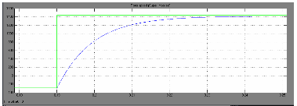
- Torque of modified voltage model flux estimation

33
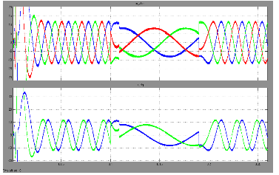
- Current and time modified voltage Model Flux Estimation
It can be seen that the accuracy of flux estimation during the startup period is improved adopting the modified voltage model estimator. Not only the maximum overshoot is reduced but also the steady-state error is decreased. The speed estimation waveforms with the modified voltage model and conventional voltage model are compared and shown in Fig 3 and Fig 4 when the ramp change in speed from 0Hz to10Hz. The actual estimated speed and speed command, are illustrated in Fig.7 From the experimental results, the estimated speed has good dynamic performance during the speed transition

Conclusion
The paper presents a model parameter estimation methodology, which allows the identification of a generic three phase induction motor model, especially in the case of slip-dependent rotor parameters. The methodology is based on analytical procedures for the solution of the resulting nonlinear least squares estimation problem, in particular the Gauss-Newton method, augmented with line search and trust region global convergence strategies. While such algorithms have been available in the field of mathematics for several years and have been used in work on parameter estimation in the past, this paper attempts the implementation of a custom designed algorithm, contrary to the use of an existing package.
This allows a better insight on how the estimation procedure works and on the reasons of a possible non-convergence. The estimation procedure is demonstrated using simple numerical examples of motors of various designs, for the estimation of the rotor equivalent circuit. Extension to full model identification with the inclusion of slip-current measurements is a simple extension to the illustrated procedure and results. More detailed numerical results will be demonstrated in future work, including comparison of the procedure with other existing implementations, in particular with evolutionary based optimization algorithms, and estimation of its robustness using actual measurements and noisy measurement sets. A speed estimator using improved rotor flux estimator based on modified voltage mode was presented in this paper. From the simulation analysis and the experimental results, satisfactory performance is achieved using the proposed speed estimator. By using modified voltage rotor flux estimator, the dc drift problem is restrained effectively, and the estimation error is reduced. So its accuracy improve the accuracy of speed estimation The proposed speed estimator has good dynamic performances during the increasing and decreasing speed periods. It is a simple speed estimator for applications.

VII. REFERENCE

[1] B. R. Williams, W. R. Schmus and D. C. Dawson, “Transmission voltage recovery delayed by stalled air conditioner compressors,” IEEE Trans. on Power Systems, vol. 7, no. 3, Aug. 1992, pp. 1173-1181.
[2] F. P. de Mello, and J. W. Feltes, “Voltage oscillatory instability caused by induction motor loads,” IEEE Trans. on Power Systems, vol. 11, no. 3, Aug. 1996, pp. 1279-1285.
[3] N. Martins, S. Gomes Jr., R. M. Henriques, C. B. Gomes, A. de Andrade Barbosa, and A. C. B. Martins, “Impact of induction motor loads in system loadability margins and damping of inter-area modes,” in Proc. 2003 IEEE-PES General Meeting, Toronto, Canada, July 13-17, 2003.
[4] J. Undrill, A. Renno, and G. Drobnjak, “Dynamics of a large induction motor load system,” in Proc. 2003 IEEE-PES General Meeting, Toronto, Canada, July 13-17, 2003.
[5] K. Morison, H. Hamadani, and L. Wang, “Practical issues in load modeling for voltage stability studies,” in Proc. 2003 IEEE-PES General Meeting, Toronto, Canada, July 13-17, 2003.
[6] K. Tomiyama, S. Ueoka, T. Takano, I. Iyoda, K. Matsuno, K. Temma, and J. J. Paserba, “Modeling of Load During and After System Faults Based on Actual Field Data,” in Proc. 2003 IEEE-PES General Meeting, Toronto, Canada, July 13-17, 2003.
[7] I. R. Navarro, O. Samuelsson, and S. Lindahi, “Automatic determination of parameters in dynamic load models from normal operation data,” in Proc. 2003 IEEE-PES General Meeting, Toronto, Canada, July 13-17, 2003.

34

[8] I. R. Navarro, O. Samuelsson, and S. Lindahi, “Influence of normalization in dynamics reactive load models,” IEEE Trans. Power Systems, vol. 18, issue 2, May 2003, pp. 972-973
[9] Z. Zhang, G. E. Dawson, and T. R. Eastham, “Evaluation of dynamic parameters and performance of deep-bar induction machines,” in Proc. IEEE-IAS Annu. Meeting, 1993, pp. 62-66.
[10] S. I. Moon and A. Keyhani, “Estimation of induction machine parameters from standstill time domain data,” in Proc. IEEE-IAS Annu. Meeting, 1993, pp. 336-342.
[11] J. R. Willis, G. J. Brock, and J. S. Edmonds, “Derivation of induction motor models form standstill frequency response tests,” IEEE Trans. Energy Conversion, vol. 4, pp. 608-615, Dec. 1989.
[12] T. A. Lipo and A. Consoli, “Modeling and simulation of induction motors with saturable leakage reactances,” IEEE Trans. Ind. Applications, vol. IA-21, pp. 180-189, Jan./Feb. 1984.
[13] A. Keyani and H. Tsai, “IGSPICE simulation of induction machines with saturable inductances,” IEEE Trans. Energy Conversion, vol. 4, pp. 118-125, Mar. 1989.
[14] L. Zai, C. L. de Marco, and T. A. Lipo, “An extended Kalman filter approach to rotor time constant measurement in PWM induction motor drives,” IEEE Trans. Ind. Applications, vol. 28, pp. 96-104, Jan./Feb. 1992.
[15] J. Holtz and T. Thim, “Identification of the machine parameters in a vector controlled induction motor drive,” Ieee Trans. Ind. Applications,
vol. 27, pp. 1111-1118, Nov./Dec., 1991.
[16] J. A. de Koch, F. S. van der Merwe, and H. J. Vermeuler, “Induction motor parameter estimation through and output error technique,” presented at the IEEE-PES Winter Meeting, Columbus, OH, 1993, Paper 93-WM 01909 EC.
[17] P. Pillay, R. Nolan, and T. Haque, “Application of genetic algorithm to motor parameter determination for transient torque calculations,” IEEE Trans. Ind. Applications, vol. 33, no 5, pp. 1273-1282, Sept./Oct. 1997.
[18] T. Phumiphak and C. Chatuthai, “Estimation of induction motor parameters based on field test coupled with genetic algorithm,” in Proc. Int. Conf. Power System Technology 2002 (PowerCon 2002), pp. 1199-1203.
[19] H. Weatherford and C. W. Brice, “Estimation of induction motor parameters by a genetic algorithm,” in Proc. 2003 Annu. Pulp and Paper Industry Technical Conference, pp. 21-28.
[20] P. Nangsue, P. Pillay, S. Conry, “Evolutionary algorithms for induction motor parameter determinations,” IEEE Trans. Energy Conversion, vol. 14, no 3, pp. 447-453, Sept./1999.
[21] B. K. Johnson and J. R. Willis, “Tailoring induction motor analytical models to fit known motor performance characteristics and satisfy particular study needs,” IEEE Trans. Power Systems, vol. 6, no 3, pp. 959-965, Aug. 1991.
[22] J. Pedra and F. Corcoles, “Estimation of induction motor double-cage model parameters from manufacturer data,” IEEE Trans. Energy Conversion, vol. 19, no 2, June 2004.
[23] M. Cirrincione, M. Pucci, G. Cirrincione, and G-A Capolino, “A new experimental application of least squares techniques for the estimation of the induction motor parameters,” IEEE Trans. Ind. Applications, vol. 39, no 5, pp. 1247-1256, Sept./Oct. 2003
[24] P. Ju, E. Handschin, Z. N. Wei, U. Schluecking, “Sequential parameter estimation of a simplified induction motor load model,” IEEE Trans. Power Systems, vol. 11, no 1, pp. 319-324, Feb. 1996.
[25] A. P. Sakis Meliopoulos, Wenzhong Gao, Shengyuan Li, G. J. Cokkinides and Roger Dougal, “Quadratized induction machine model for power flow analysis,” Proceedings of the Second IASTED International Conference, EuroPES, Crete, Greece, pp 194-199, June 25-28, 2002.
[26] G. K. Stefopoulos and A. P. Meliopoulos, “Induction motor load dynamics: Impact on voltage recovery phenomena,” Proceedings of the 2005/2006 IEEE Transmission and Distribution Conference and
Exposition, Dallas, TX, May 21-25, 2006.
[27] A. P. Meliopoulos, G. J. Cokkinides, and G. K. Stefopoulos, “Voltage stability and voltage recovery: Effects of electric load dynamics,” in Proc. of the 2006 IEEE International Symposium on Circuits and
Systems, Island of Kos, Greece, May 21-24, 2006.
[28] G. K. Stefopoulos and A. P. Meliopoulos, “Quadratized Three-Phase Induction Motor Model for Steady-State and Dynamic Analysis,” in Proc. of the 38th North America Power Symposium, Carbondale, IL, USA, Sept. 17-19, 2006, pp. 79-89.
[29] J. E. Dennis, Jr., R. B. Schnabel, Numerical methods for unconstrained optimization and nonlinear equations. SIAM 1996.

35

